Report
Strategy



Wireless Devices 2000
Consulting Report

Executive Summary: This report provides a survey of available and planned wireless computing devices. The current market for such devices is highly fragmented. A wide variety of devices can be made wireless with the addition of wireless modems. However, very few devices are currently purpose-built for wireless use. Because of the lack of widely adopted standards, it is currently not possible to easily develop for multiple different devices. This report lays the foundation for selecting a device on which to deploy wireless applications by providing the critical technical information required for making the selection.

Purpose: This report provides a survey of available and planned portable computing devices to determine which are suitable for wireless delivery of medical, educational and business information and associated application functionality. It is one of a family of reports on wireless technology that include:

- Wireless Devices
- Wireless Application Protocols
- Wireless Application Service Providers
- Wireless Application Development Tools
- Recommendations for Developers of Wireless Applications

Taken together these reports provide an overview of the set of technologies required to deliver wireless data and application services and products. The final recommendations report provides guidance on the selection of the appropriate technologies and makes a limited number of recommendations for specific solutions.

Problem: Companies that wish to develop and deploy wireless data services or wireless applications face the challenges of delivering useful application functionality and business information through a device appropriate for mobile use. The current market for wireless computing devices is highly fragmented. A wide variety of devices can be made wireless with the addition of wireless modems. However, very few devices are currently purpose-built for wireless use. In addition, there are a number of different and non-compatible networking and radio technologies being deployed across these devices and modems. This means that development of wireless applications and data services requires careful selection of:

- a specific model of device on which to deploy the application;
- which supports a specific application protocol;
- supported by a specific set of wireless service providers;
- who offer a specific set of development tools

Because of the lack of widely adopted standards (or more accurately, because of the adoption of multiple different de facto standards by competing vendors), this report lays the foundation for selecting a device on which to deploy wireless applications by providing the critical technical information required for making the selection.

Discussion: There are a wide variety of devices that could potentially be used for mobile or wireless applications. They range from wireless application protocol-enabled cellular phones to purpose-built wireless palmtops to laptops with wireless modems. Each of these potential platforms for wireless applications has strengths and weaknesses.

Cellular phones – Cellular phone manufacturers and service providers have been attempting to deploy data services on the latest phones. These phones generally have very small screens appropriate for displaying caller information (e.g. phone numbers, names) and short messages (e.g. pager messages). The small screen size raises useability issues for these devices for wireless data services and applications.

Stylus-based palmtop devices - The form factor of stylus-based palmtop devices (e.g. Palm Pilot) is convenient for carrying in a pocket and sufficient for retrieving contact-manager type information. However, the screen is often too small for information intensive task such as managing email or doing web-based research. The limited graphics support and low resolution of some devices also makes it difficult to deploy engaging applications.

Keyboard-based palmtop devices - combine the small form factor inherent in all palm devices with the potential awkward usability of a keyboard-based laptop.

eBook devices - The eBook type devices have an ideal screen form factor for running handheld business applications. In addition, the larger case offers the potential for significantly more processing, memory, storage and connectivity options than the smaller palmtops. However, that potential has not been met by the manufacturers, whose products lack color, touch screens, power, memory and connectivity.

Tablet-type laptop computers – Tablet computers, bring the power of a desktop system, the expandability of a keyboard-based laptop in a form factor that may be more appropriate for one-handed use. However, there are very few of these types of devices on the market.

Keyboard-based laptop computers - Laptop computers, while fine for desktop replacement systems, with their fast processors, high memory, disk storage and large screens, they have too large a form factor and take too long to boot to be a useful handheld mobile solution.

There are a few critical technical features that must be considered when selecting a device on which to deploy wireless data services or wireless applications.

Price – The suggested retail (list) price can determine whether the device on which an application is deployed is accepted by the target market. However useful the application, if the device is deemed to be too expensive, adoption of the application or service will be slow and may ultimately be rejected by the market.

Screen Dimensions – These are the dimensions in inches and centimeters of the physical dimensions of the screen of the device. This dimension is critical to the overall ease of use of a device. A screen that is too small, independent of resolution, will be more difficult to read, limit the amount of information that can be displayed and be more difficult to interact with.

Screen Resolution – This is the screen resolution in pixels. Screen resolution determines how much detail can be displayed for a given physical screen size. For any specific physical screen size, higher resolution allows for crisper text fonts and more detailed graphics.

Screen Color – Many hand-held devices are still being sold with monochrome (black and white) displays. Color displays have been introduced by most manufacturers, but the slightly higher cost and the slight reduction in display contrast have slowed adoption.

Device Dimensions – These are the physical dimensions in inches and centimeters of the device as a whole. These dimensions determine how convenient or unwieldy the device will be for daily use. In particular, for those applications that require freedom of movement or free hands, the smaller palm-top devices may be more appropriate than larger tablet sized devices.

Device Weight: The total operating weight of the device in pounds and kilograms. The operating weight is the weight of the device as it is being used (e.g. including required add-on modems, but not including extra batteries, rechargers, etc.)

Processor – What processing chip or architecture is used to build the device. This can determine what operating system and applications can be run on the device and how fast the device will perform.

Operating System – What operating system is used by the device. This determines what types of applications can be run on the device and what tools are available for building those applications.

Memory – How much random access memory is included on the device. This can determine how sophisticated and application can be loaded on the device and how much local data can be retained (e.g. for web caching)

Expansion slots – If available, what types of expansion slots or connections are available on the device. An expansion slot on a device can allow a wireless modem to be used – thus allowing a non-wireless device to become a wireless device.

Storage – If appropriate, how much disk storage space is available on the device. This can be valuable if running a large application or attempting to work with a large amount of data. The download time for large applications or download time for large amounts of data (e.g. large images, movies) can be too long for effective use in the field.

Wireless Protocol – How does the device communicate with the Internet or other data networking systems.

Service Providers – What cellular phone companies, paging companies or wireless data companies support this device in what regions of the countries.

Approach: For this report we have focused on mobile devices that either have built-in wireless data service or can be extended to support wireless data services. We have focused largely on palmtops and tablet computing devices. The cell phones, pagers and keyboard-based palmtops did not have large enough screens to be appropriate for this report. (The exceptions were the Qualcomm-Kyocera Pdq SmartPhone and Handspring VisorPhone. Both of these are based on the Palm platform and we categorized as palmtop devices rather than cell phones.) eBooks seemed to have a lot of potential during our early investigation. However, lacking built-in wireless support and lacking expansion slots they cannot be considered at this point for wireless computing. Keyboard-based laptops can all be extended to use as wireless devices, thus no real purpose would be served by providing a yet another survey of laptop computers. For tablet devices we surveyed a large number of laptop manufacturers in hopes of identifying more suppliers.

Devices

Stylus-based Palm Devices
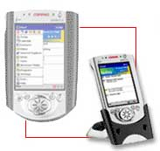
Compaq iPaqH3650 Pocket PC +
Sierra Wireless Aircard 300
$481-599+$279-479 = $760-1078

A pricey but world-class device which when combined with a wireless modem becomes a premier wireless device. With one of the largest screens, highest resolution, color display and one of the fastest processors, this is the Cadillac of mobile devices.

Screen Dimensions: 3.77” diagonal
Screen Resolution: 240x320
Screen Color: 4096 Colors
Device Dimensions: 5.11”x3.28”x0.62”
Device Weight: 6.3 oz.

Processor: Intel/StrongARM SA-1110 206Mhz
Operating System: Windows CE
ROM Memory: 16MB
RAM Memory: 32MB
Expansion: 1 Type II PC Card slot
Storage: NA
Wireless Protocol: IP over CDPD
Service Providers: goamerica.com, et. al.
Battery Life: unknown

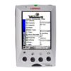
Compaq Aero 2150 +
Sierra Wireless Aircard 300
$299+$279-479 = $578-778

A moderately priced device which when combined with a wireless modem becomes a solid wireless device with one of the largest screens and highest resolution monochrome display.

Screen Dimensions: 3.77” diagonal
Screen Resolution: 240x320
Screen Color: Color
Device Dimensions: 5.27”x3.34”x0.78”
Device Weight: 10.92 oz.

Processor: 70 MHz NEC MIPS RISC
Operating System: Windows CE
RAM Memory: 16MB up to 24MB
Expansion: : 1 Type 1 CompactFlash slot
Storage: NA
Wireless Protocol: IP over CDPD
Service Providers: goamerica.com, et. al.
Battery Life: up to 14 hours

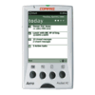
Compaq Aero 1550 +
Sierra Wireless Aircard 300
$299+$279-479 = $578-778

A moderately priced device which when combined with a wireless modem becomes a solid wireless device with one of the largest screens and highest resolution monochrome display.

Screen Dimensions: 3.77” diagonal
Screen Resolution: 240x320
Screen Color: Monochrome
Device Dimensions: 5.13”x3.11”x0.5”
Device Weight: 5.2 oz.

Processor: 70 MHz NEC MIPS RISC
Operating System: Windows CE , Pocket PC
ROM Memory: 16MB
RAM Memory: 16MB
Expansion: PC Card Type I
Storage: NA
Wireless Protocol: IP over CDPD
Service Providers: goamerica.com, et. al.
Battery Life: up to 14 hours

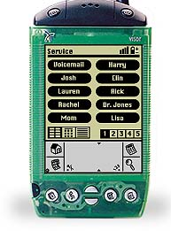
Handspring VisorPhone
$249 + $299 = $598

Newly announced joint venture product between Handspring and an unnamed cell phone company. The “VisorPhone” is a packaged product with a Handspring Visor and a plug-in cell phone for the Visor’s Springboard expansion slot.

Screen Dimensions: 3” diagonal
Screen Resolution: 160x160
Screen Color: Monochrome
Device Dimensions: 3.0”x0.7”x4.8”
Device Weight: 5.4 oz + unknown

Processor: Motorola/Dragonball 16Mhz
Operating System: Palm OS 3.1
RAM Memory: 8MB
Expansion: 1 Springboard slot used by cell phone
Storage: None
Wireless Protocol: CDMA, TDMA, WAP unknown
Service Providers: Unknown
Battery Life: unknown
Comments: Available US December 2000 (though may be available online in October). Asian and European plans unknown.

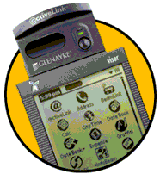
Handspring Visor Deluxe + @ctiveLink Bundle
$428

Combining the Handspring Visor Deluxe and the Glenayre @activeLink Springboard module, this device provides 24 hour connectivity. The module stays active even when separated from the Visor to receive email and interactive messages.

Screen Dimensions: 3” diagonal
Screen Resolution: 160x160
Screen Color: Monochrome
Device Dimensions: 3.0”x0.7”x4.8”
Device Weight: 5.4 oz + 3.2 oz = 8.6 oz

Processor: Motorola/Dragonball 16Mhz
Operating System: Palm OS 3.1
RAM Memory: 8MB
Expansion: 1 Springboard slot used by @ctiveLink
Storage: None
Wireless Protocol: CDMA, TDMA, WAP unknown
Service Providers: SkyTel Skywriter
Battery Life: unknown
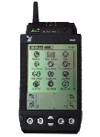

Handspring Visor Deluxe +
Novatel Minstrel S Wireless Modem
$249 + $369 = $618

Combining the Handspring Visor Deluxe and the Novatel Minstrel S wireless CDPD modem.

Screen Dimensions: 3” diagonal
Screen Resolution: 160x160
Screen Color: Monochrome
Device Dimensions: 3.0”x0.7”x4.8”
Device Weight: 5.4 oz + unknown

Processor: Motorola/Dragonball 16Mhz
Operating System: Palm OS 3.1
RAM Memory: 8MB
Expansion: 1 Springboard slot used by modem
Storage: None
Wireless Protocol: CDMA, WAP unknown
Service Providers: ATT Wireless, GoAmerica, Verizon
Battery Life: unknown

Handspring Visor + Novatel Minstrel S
$149 + $269 = $418

Combining the Handspring Visor and the Novatel Minstrel S wireless CDPD modem.

Screen Dimensions: 3” diagonal
Screen Resolution: 160x160
Screen Color: Monochrome
Device Dimensions: 3.0”x0.7”x4.8”
Device Weight: 5.4 oz + unknown

Processor: Motorola/Dragonball 16Mhz
Operating System: Palm OS 3.1
RAM Memory: 2MB
Expansion: 1 Springboard slot used by modem
Storage: None
Wireless Protocol: CDMA, TDMA, WAP unknown
Service Providers: ATT Wireless, GoAmerica, Verizon
Battery Life: unknown


Palm Vx + RealVision “PalmPhone” $399+$299= $698

Based on Palm Vx plus clip-on cell phone.

Screen Dimensions: 4.1” diagonal
Screen Resolution: 160x160
Screen Color: Monochrome
Device Dimensions: 4.7”x3.2”x0.4”
Device Weight: 4.0 oz + unknown

Processor: Motorola/Dragonball
Operating System: Palm OS V3.3
RAM Memory: 8MB
Expansion: None
Storage: None
Wireless Protocols: GSM-only, WAP unknown
Service Providers: Unknown
Battery Life: unknown
Comments: Available Asia/Europe early 2001 No US plans to date.

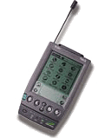
Palm IIIe + Novatel Wireless Minstrel III $149-219+$369= $518-588

Base model Palm III plus clip-on CDPD wireless modem.

Screen Dimensions: 4.1” diagonal
Screen Resolution: 160x160
Screen Color: Monochrome
Device Dimensions: 5.5”x3.2”x1.0”
Device Weight: 6.0 oz + 5.4 oz = 11.4

Processor: Motorola/Dragonball
Operating System: Palm OS V3.1
RAM Memory: 2MB
Expansion: None
Storage: None
Wireless Protocols: CDPD, WAP unknown
Service Providers: ATT Wireless, GoAmerica, Verizon
Battery Life: unknown

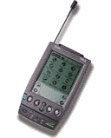
Palm IIIxe + Novatel Wireless Minstrel III $269+$369= $638

Palm III with added memory and updated OS plus clip-on CDPD wireless modem.

Screen Dimensions: 4.1” diagonal
Screen Resolution: 160x160
Screen Color: Monochrome
Device Dimensions: 5.5”x3.2”x1.0”
Device Weight: 6.0 oz + 5.4 oz = 11.4

Processor: Motorola/Dragonball
Operating System: Palm OS V3.5
RAM Memory: 8MB
Expansion: None
Storage: None
Wireless Protocols: CDPD, WAP unknown
Service Providers: ATT Wireless, GoAmerica, Verizon
Battery Life: unknown
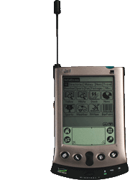

Palm Vx + Novatel Wireless Minstrel V $399+$99-299= $498-698

Based on Palm V plus clip-on modem.

Screen Dimensions: 4.1” diagonal
Screen Resolution: 160x160
Screen Color: Monochrome
Device Dimensions: 4.7”x3.2”x0.4”
Device Weight: 4.0 oz + unknown

Processor: Motorola/Dragonball
Operating System: Palm OS V3.3
RAM Memory: 8MB
Expansion: None
Storage: None
Wireless Protocols: CDPD, WAP unknown
Service Providers: ATT Wireless, GoAmerica, Verizon
Battery Life: unknown

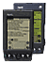
Palm Computing Palm VII
$399

Screen Dimensions: 3” diagonal
Screen Resolution: 160x160
Screen Color: Monochrome
Device Dimensions: 3.25”x5.25”x0.75”
Device Weight: 6.7 oz

Processor: Motorola/Dragonball
Operating System: Palm OS V3.2
Memory: 2MB
Expansion: None
Storage: None
Wireless Protocol: OmniSky (Palm.net)
Service Providers: Omnisky (Palm.net)
Battery Life: unknown
Comments: Built-in wireless based on OmniSky service. Proprietary email, web, business information and paging services supported.

Palm Computing Palm VIIx
$449

Screen Dimensions: 3” diagonal
Screen Resolution: 160x160
Screen Color: Monochrome
Device Dimensions: 3.25”x5.25”x0.75”
Device Weight: 6.7 oz

Processor: Motorola/Dragonball
Operating System: Palm OS V3.5
Memory: 8MB
Expansion: None
Storage: None
Wireless Protocol: OmniSky (Palm.net)
Service Providers: Omnisky (Palm.net)
Battery Life: unknown
Comments: Built-in wireless based on OmniSky service. Proprietary email, web, business information and paging services supported.

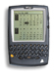RIM Blackberry Model 957
$499

Screen Dimensions: 20 lines
Screen Resolution: 20 lines
Screen Color: Monochrome
Device Dimensions: 4.6”x3.1”x0.70”
Device Weight: 5.3 oz

Processor: Intel 386
Operating System: Blackberry
Memory: 5MB FlashMemory + 512KB SRAM
Expansion: None
Storage: None
Wireless Protocol: PCS CDPD, WAP, J2ME
Service Providers: BellSouth Mobitex
Battery Life: unknown

Qualcomm-Kyocera Pdq SmartPhone
$799

This is the first integrated cell phone and Palm PDA device on the market. Based on the old Palm III platform, it is a bit clunky compared to its newest competitors. It is however available immediately and well supported by the service providers.

Screen Dimensions: unknown
Screen Resolution: 160x240
Screen Color: Monochrome
Device Dimensions: 6.2”x2.6”x1.4”
Device Weight: 10 oz

Processor: Unknown
Operating System: Palm OS 3.1
Memory: 2MB
Expansion: None
Storage: None
Wireless Protocol: CDMA Analog & Digital (Pdq 800), CDMA PCS (Pdq 1900), 14.4kbps
Service Providers: Sprint, Verizon
Battery Life: unknown
Comments: <2.5 hours connect, <40 hours standby

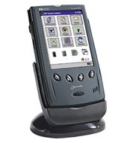
Hewlett Packard Jordana 545 + Novatel Merlin PC Card Wireless Modem
$499+$299=$798

Screen Dimensions: unknown
Screen Resolution: 320x240
Screen Color: 4096 Colors
Device Dimensions: 5.2”x3.1”x0.6”
Device Weight: 9.1 oz

Processor: 133 Mhz
Operating System: Windows CE
Memory: 16MB
Expansion: 1 PC Card slot used by modem
Storage: None
Wireless Protocol: CDPD
Service Providers: ATT Wireless, GoAmerica, Verizon
Battery Life: unknown
Comments: <5 hours battery life

Hewlett Packard Jordana 548 + Novatel Merlin PC Card Wireless Modem
$599+$299=$898

Screen Dimensions: unknown
Screen Resolution: 320x240
Screen Color: 4096 Colors
Device Dimensions: 5.2”x3.1”x0.6”
Device Weight: 9.1 oz

Processor: 133 Mhz
Operating System: Windows CE
Memory: 32MB
Expansion: PC Card slot used by modem
Storage: None
Wireless Protocol: CDPD
Service Providers: ATT Wireless, GoAmerica, Verizon
Battery Life: unknown
Comments: <5 hours battery life

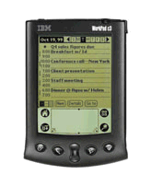
IBM Workpad + Novatel Minstrel III
$299+$369= $668

Screen Dimensions: 4.1” diagonal
Screen Resolution: 160x160
Screen Color: Monochrome
Device Dimensions: 5.5”x3.2”x1.0”
Device Weight: 6.0 oz + 5.4 oz = 11.4

Processor: Motorola/Dragonball
Operating System: Palm OS 3.1
Memory: 2MB
Expansion: None
Storage: None
Wireless Protocol: CDPD
Service Providers: ATT Wireless, GoAmerica, Verizon
Battery Life: unknown
Comments: This is IBM’s rebranded Palm III.
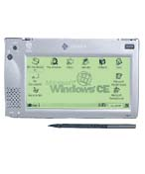

Casio PA-2400W + Novatel Merlin PC Card Wireless Modem
$unknown+ $299=$unknown

Screen Dimensions: unknown
Screen Resolution: 480x240
Screen Color: Monochrome
Device Dimensions: 7.0”4.2”x0.82”
Device Weight: 13 oz

Processor: SH3 80Mhz
Operating System: Windows CE 2.11
Memory: 8MB
Expansion: 1 PC Card Slot used by modem, 1 CompactFlash slot
Storage: None
Wireless Protocol: CDPD
Service Providers: ATT Wireless, GoAmerica, Verizon
Battery Life: 15 hours

Tablet Devices

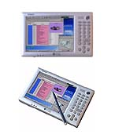
Casio FIVA Tablet (MPC-501M40E)+ Novatel Merlin PC Card Wireless Modem
$unknown+ $299=$unknown

Screen Dimensions: 6.7” diagonal
Screen Resolution: 800x600
Screen Color: Color
Device Dimensions: 8.2”x5.1”x1.3”
Device Weight: 1.88 lbs

Processor: 200MHz National Geode
Operating System: Windows 98
Memory: 32MB upgradable to 96MB
Expansion: 1 PC Card Slot used by modem
Storage: 6GB
Wireless Protocol: IP over CDPD
Service Providers: ATT Wireless, GoAmerica, Verizon
Battery Life: 3 hours

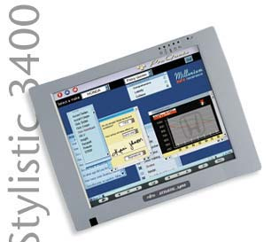
Fujitsu 3400X +
Sierra Wireless Aircard 300
$unknown+$279-479 = $unknown

Screen Dimensions: 10.4
Screen Resolution: 1024x768
Screen Color: 256K Color
Device Dimensions: 11.2”x8.5”x1.1”
Device Weight: 3.21 lbs

Processor: 400 MHz Intel Pentium III
Operating System: Windows 98, NT, 2000
Memory: 64MB up to 192MB
Expansion: 1 Type II PC Card slot
Storage: 6 GB
Wireless Protocol: IP over CDPD
Service Providers: ATT Wireless, GoAmerica, Verizon
Battery Life: unknown

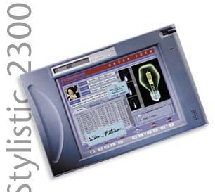
Fujitsu 2300 +
Sierra Wireless Aircard 300
$unknown+$279-479 = $unknown

Screen Dimensions: 8.4”
Screen Resolution: 800x600
Screen Color: 262,144 Colors
Device Dimensions: 11.1”x7.4”x1.6”
Device Weight: 3.9 lbs

Processor: 233 MHz Intel Pentium
Operating System: Windows 98, Windows NT
Memory: 32MB up to 160MB
Expansion: 2 Type II PC Card slots
Storage: 6GB
Wireless Protocol: IP over CDPD
Service Providers: ATT Wireless, GoAmerica, Verizon
Battery Life: unknown

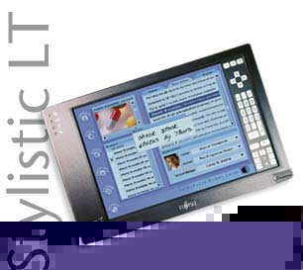
Fujitsu Stylistic LT C-500 +
Sierra Wireless Aircard 300
$unknown+$279-479 = $unknown

Screen Dimensions: 8.4”
Screen Resolution: 800x600
Screen Color: 262,144 Colors
Device Dimensions: 9.6”x6.3”x1.1”
Device Weight: 2.5 lbs

Processor: 500 MHz Intel Celeron, 100MHz bus
Operating System: Windows 98, Windows 2000
Memory: 64MB, 128MB or 256MB
Expansion: 1 Type II PC II PC Card slot, 1 Co, 1 CompactFlash sloth sloreless Protocol: IP over CDPD
Service Providers: ATT Wireless, GoAmerica, Verizon
Battery Life: unknown

Fujitsu Stylistic LT +
Sierra Wireless Aircard 300
$unknown+$279-479 = $unknown

Screen Dimensions: 8.4”
Screen Resolution: 800x600
Screen Color: 262,144 Colors
Device Dimensions: 9.6”x6.3”x1.1”
Device Weight: 2.4 lbs

Processor: 233 MHz Intel Pentium
Operating System: Windows 98, Windows NT
Memory: 64MB
Expansion: 2 Type II PC Card slots
Storage: 4.3GB
Wireless Protocol: IP over CDPD
Service Providers: ATT Wireless, GoAmerica, Verizon
Battery Life: unknown

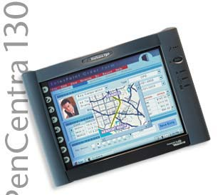
Fujitsu PenCentra 130 +
Sierra Wireless Aircard 300
$unknown+$279-479 = $unknown

Screen Dimensions: 8” diagonal
Screen Resolution: 640x480
Screen Color: 256 Colors
Device Dimensions: 8.9”x6.5”x1.3”
Device Weight: 2 lbs

Processor: 131 MHz NEC VR4121 RISC
Operating System: Windows CE 2.11
RAM Memory: 16MB up to 48MB
Flash Memory: 8MB up to 16MB
ROM Memory: 24MB
Expansion: 2 PC Card slots
Storage: none
Wireless Protocol: IP over CDPD
Service Providers: ATT Wireless, GoAmerica, Verizon
Battery Life: 10 hours

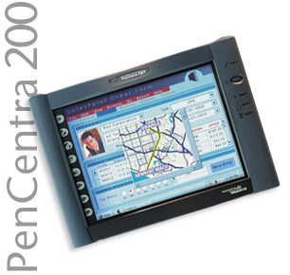
Fujitsu PenCentra 200 +
Sierra Wireless Aircard 300
$unknown+$279-479 = $unknown

Screen Dimensions: 8” diagonal
Screen Resolution: 640x480
Screen Color: 256 Colors
Device Dimensions: 8.9”x6.5”x1.3”
Device Weight: 2 lbs

Processor: 129 MHz Toshiba TX3922 RISC
Operating System: Windows CE 2.11
RAM Memory: 32MB to 64MB
Flash Memory: 16MB
ROM Memory: 24MB
Expansion: 1 PC Card slot
Storage: none
Wireless Protocol: IP over CDPD
Service Providers: ATT Wireless, GoAmerica, Verizon
Battery Life: 10 hours

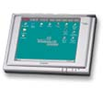
Hitachi HPW-630ETR (ePlate) +
Sierra Wireless Aircard 300
$unknown+$279-479 = $unknown

Screen Dimensions: 8.2” diagonal
Screen Resolution: 640x480
Screen Color: 64k Colors
Device Dimensions: 9.3”x6.7”x1.3”
Device Weight: 42.3 oz

Processor: SH-4 128MHz RISC
Operating System: Windows CE 2.12
Memory: 32MB
Expansion: 1 Type II PC Card slot, 1 CompactFlash slot
Storage: None
Wireless Protocol: IP over CDPD
Service Providers: ATT Wireless, GoAmerica, Verizon
Battery Life: 9 hours
Comment: Rugged case designed for outdoor/indoor use.

Hitachi HPW-600ETM (ePlate) +
Sierra Wireless Aircard 300
$1299+$279-479 = $1578-1778

Screen Dimensions: 7.5” diagonal
Screen Resolution: 640x480
Screen Color: 64K Colors
Device Dimensions: 8.7”x6.3”x1.2”
Device Weight: 29.6 oz

Processor: SH-4 128MHz RISC
Operating System: Windows CE Pro 3.0
Memory: 32MB (16MB available in ET)
Expansion: 1 Type II PC Card slot, 1 CompactFlash slot
Storage: None
Wireless Protocol: IP over CDPD
Service Providers: ATT Wireless, GoAmerica, Verizon
Battery Life: 9 hours

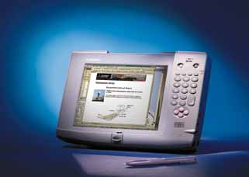Mitsubishi AmiTY CP +
Sierra Wireless Aircard 300
$unknown+$279-479 = $unknown

Screen Dimensions: 7.5” diagonal
Screen Resolution: 640x480
Screen Color: 256 Colors
Device Dimensions: 8.75”x11.375”x0.95”
Device Weight: 2.2 lbs

Processor: Intel Pentium 166MHz
Operating System: Windows 95
Memory: up to 96MB
Expansion: 2 Type II PC Card slots,
Storage: 1.6 GB
Wireless Protocol: IP over CDPD
Service Providers: ATT Wireless, GoAmerica, Verizon
Battery Life: unknown

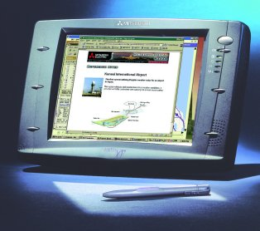
Mitsubishi AmiTY XP +
Sierra Wireless Aircard 300
$unknown+$279-479 = $unknown

Screen Dimensions: 8.5” diagonal
Screen Resolution: 800x600
Screen Color: 256k Colors
Device Dimensions: 10.32”x7.09”x1.65”
Device Weight: 2.7 lbs

Processor: Intel Pentium 166MHz
Operating System: Windows 98
Memory: 32MB to 64MB
Expansion: 2 Type II PC Card slots,
Storage: 1.6 GB
Wireless Protocol: IP over CDPD
Service Providers: ATT Wireless, GoAmerica, Verizon
Battery Life: unknown

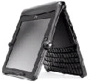
Vadem Clio +
Sierra Wireless Aircard 300
$999+$279-479 = $1278-1478

Screen Dimensions: 9.4”
Screen Resolution: 640x480
Screen Color: 256 Colors
Device Dimensions: 8.75”x11.375”x0.95”
Device Weight: 3 lbs

Processor: NEC VR4111 MIPS
Operating System: Windows CE 2.11
Memory: 16MB
Expansion: 1 Type II PC Card slot, 1 CompactFlash slot
Storage:
Wireless Protocol: IP over CDPD
Service Providers: ATT Wireless, GoAmerica, Verizon
Battery Life: 12 hours

References

The information in this report was collected from over 50 different sources such as manufacturer web sites, industry web sites, product review web sites, online periodicals, press announcements, online sales web sites and direct contact with manufacturer representatives. These sources included:

3Com
Acer
ACT
Aether
Alcam
AMS
Apple
ARM Computer
AST
ASUS
ATT Wireless
Brick Computer
BSI
Casio
ChemBook
Cisco
C/Net
Compaq
CompUSA
CTX
Dell
Everybook
Fujitsu
FutureTech
Gateway
GoAmerica
Handspring
Hewlett-Packard
Hitachi
IBM
IDEO
KDS
Kycera
Matsucom
MaxTech
Metrobook Computer
Micron
Microsoft
Mitsubishi
Motorola
NEC
Nextel
Novatel
NuvoMedia
Omnisky
Palm
Panasonic
ProStar
Proxim
Qualcomm
Quanta
Qubit
RIM
RCA
Ricoh
Rockwell
Royal
S3
Sceptre
Sharp
Shea
Sierra
Sprint
Socket
Softbook
Sony
Symbol
Tagram
TigerDirect
Toshiba
Transmeta
Twinhead
Umax
Verizon
Via
Winbook
Windrover
Xybernaught

